Isabel Ke

Guli project-section screenshot

Contents

Login 2

Home section 2

Category section 3

Product section 3

Role section 4

# Login



# Home section

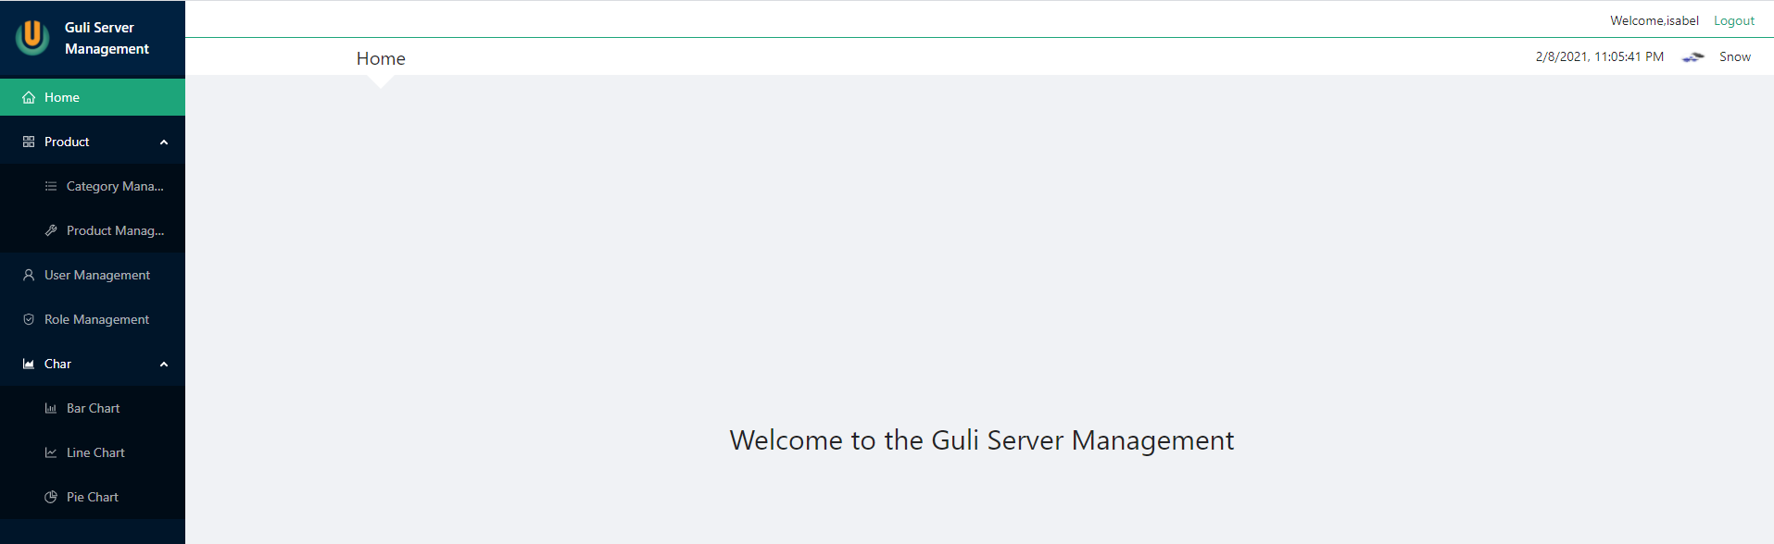

# Category section

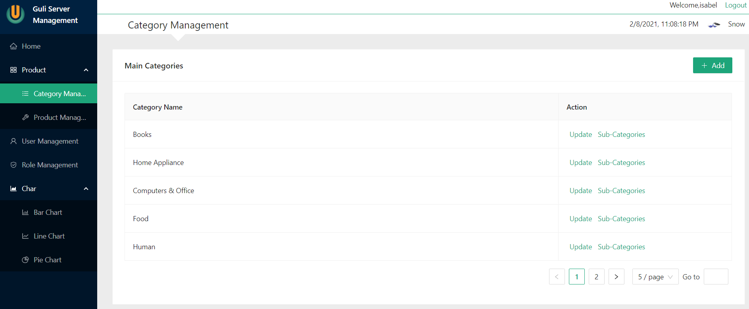

# Product section

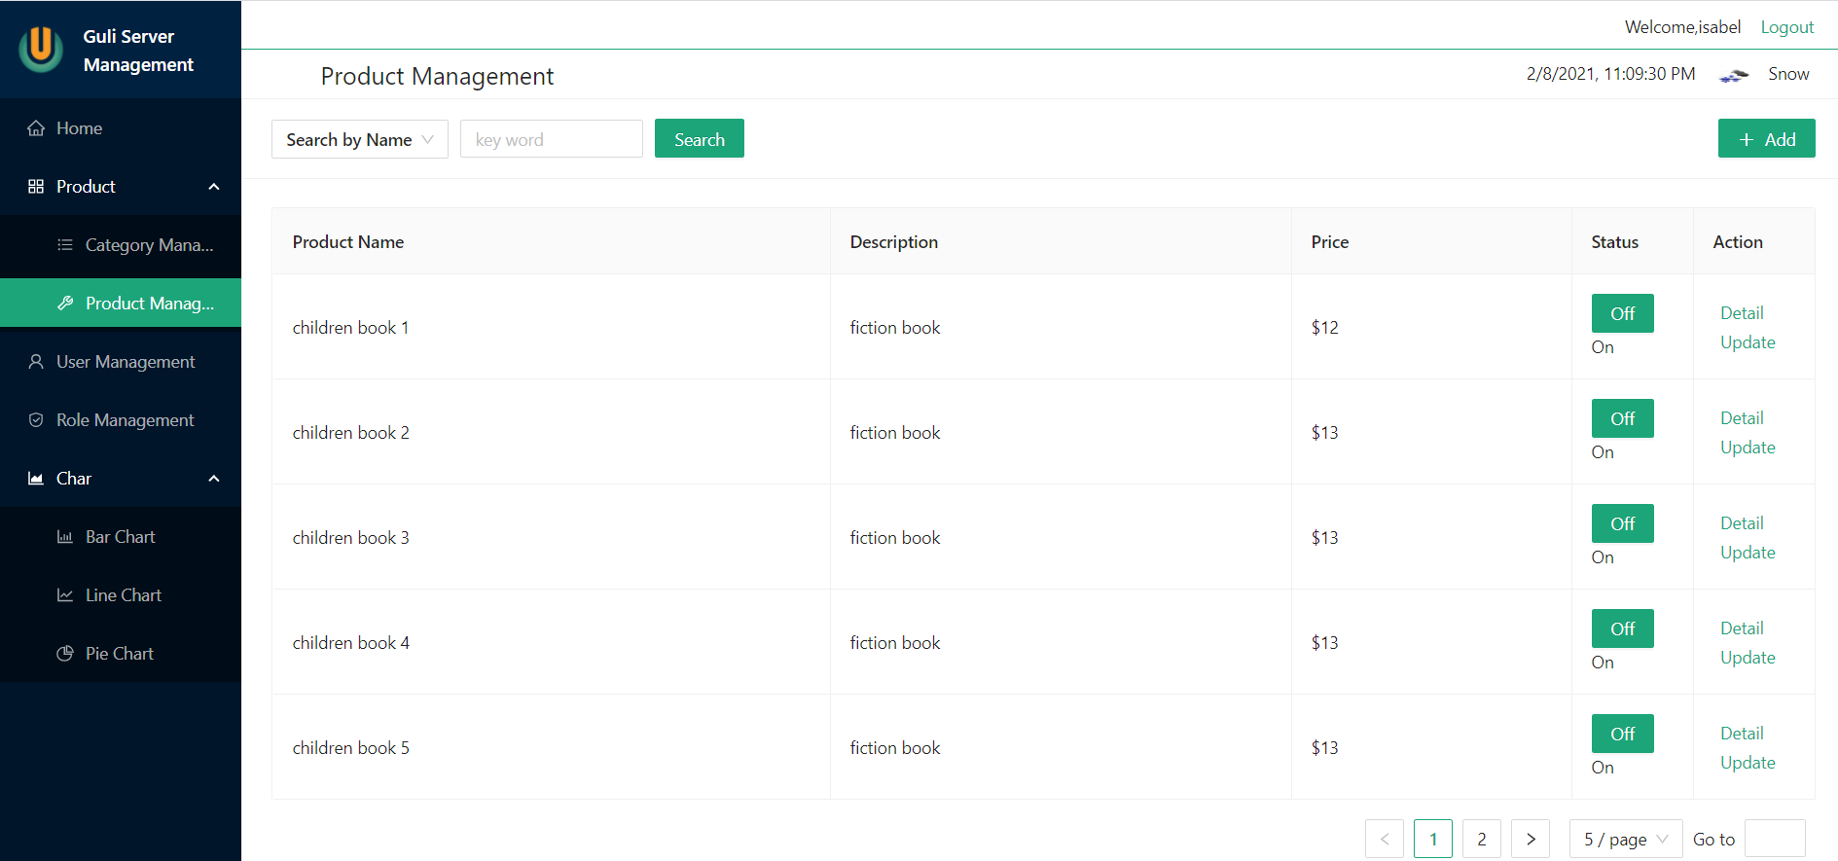

# Role section

